Chapter15 Environment name: class:

1.掌握空气中各物质的占比
composition |  | percentage
nitrogen |  | 78%
oxygen |  | 21%
Carbon dioxide |  | 1%
Noble gases | Argon
 | Neon
 | Helium

1. A new planet has been discovered and its atmosphere has been analysed.
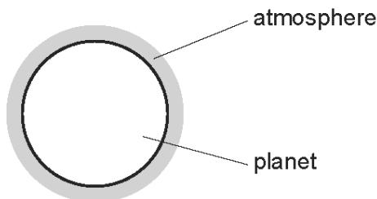
The table shows the composition of the atmosphere.
gas | percentage by volume
carbon dioxide | 4
nitrogen | 72
oxygen | 24

2. Which gases are present in the atmosphere of the planet in a higher percentage than they are in the Earth’s atmosphere? （ ）
A carbon dioxide and oxygen
B carbon dioxide only
C nitrogen and oxygen
D nitrogen only

3. Argon is a noble gas used to fill light bulbs.
What is the approximate percentage of argon in air? （ ）
A 1% B 20% C 79% D 99%

2. 掌握各污染气体的来源和危害
Pollutant | How is it formed? | What harm does it do?
carbon dioxide, CO₂ | Complete combustion of carbon-containing fuels in a plentiful supply of air | global warming,
Carbon monoxide, CO | incomplete combustion of carbon-containing  fuels that contain carbon.eg: in car engines | toxic/poisonous gas
Sulfur dioxide, SO₂ | Forms when sulfur compounds in the fossil fuels burn. | acid rain.
Nitrogen oxides,  NO and NO₂ | form when the nitrogen and oxygen in air react together inside hot motor engines | acid rain, photochemical smog(光化学烟雾) and respiratory problems
methane | methane from the decomposition of  vegetation and waste gases from digestion in animals | global warming,
particulates： | form in the incomplete combustion of fuels that contain carbon; for example, particles of soot（煤灰） from diesel engines | linked to respiratory/ breathing problems, and cancer

1. Coal is a fossil fuel.
Which gas is not formed when coal burns? （ ）
A carbon dioxide B carbon monoxide C methane D sulfur dioxide

2. Carbon monoxide is an air pollutant produced when petrol is burned in car engines.
Why is carbon monoxide considered to be an air pollutant? （ ）
A It causes global warming.
B It causes the corrosion of buildings.
C It is a greenhouse gas.
D It is poisonous.

3. Which air pollutant is not made when coal burns in a power station? （ ）
A carbon monoxide B lead compounds C nitrogen oxides D sulfur dioxide

4. Which statement about air pollutants is not correct? （ ）
A Carbon monoxide is formed from the complete combustion of petroleum.
B Lead compounds are formed from some types of petrol.
C Oxides of nitrogen are formed from the combustion reactions inside car engines.
D Sulfur dioxide is formed from the combustion of coal.

3. 掌握酸雨的危害以及处理方式
1.It attacks stonework in buildings - especially limestone and marble,
2.it acidifies rivers and lakes, killing fish and other river life;
3.it kills trees and insects.

处理方式：Sulfur dioxide SO₂：
1.reducing emissions of sulfur dioxide by using low-sulfur fuels and flue gas
2.desulfurisation with calcium oxide
⭐Nitrogen oxides, NO and NO₂：Catalytic convertor
2NO + 2CO → N₂ + 2CO₂
2NO₂ + 4CO → N₂ + 4CO₂

1. A factory burns coal with a high sulfur content.
Which pollutant is most likely to lead to the death of trees? （ ）
A carbon dioxide B carbon monoxide C lead compounds D sulfur dioxide

2. Statement 1: The burning of fossil fuels containing sulfur is a cause of ‘acid rain’.
Statement 2: Acid rain contains sulfur dioxide which is formed when sulfur compounds burn in the air.
Which of the following is true? （ ）
A Both statements are correct and statement 2 explains statement 1.
B Both statements are correct, but statement 2 does not explain statement 1.
C Statement 1 is correct but statement 2 is incorrect.
D Statement 2 is correct but statement 1 is incorrect.

3. Acid rain is formed when SO2 and oxides of nitrogen dissolve in rain water.
Which problem is not caused by acid rain? （ ）
A breathing difficulties
B dying trees
C erosion of statues
D lowered pH of lakes

4. Oxides of nitrogen are found in polluted air.
Which statement about oxides of nitrogen is correct? （ ）
A Oxides of nitrogen are formed by the reaction of nitrogen with oxygen during the fractional distillation of liquid air.
B Oxides of nitrogen are formed in a car engine by the reaction of petrol with nitrogen from the air.
C Oxides of nitrogen are removed from exhaust gases by reaction with carbon dioxide in a catalytic converter.
D Oxides of nitrogen are removed from exhaust gases by reduction in a catalytic converter.

5. Coal is a solid fossil fuel.
Name two other fossil fuels.............................................................................................
Two of the elements present in a sample of coal are carbon and sulfur.
A sample of coal was heated in the absence of air and the products included water, ammonia and hydrocarbons.
Name three other elements present in this sample of coal...........................................
Sulfur, present in coal, is one major cause of acid rain. Sulfur burns to form sulfur dioxide which reacts with rain water to form sulfuric acid.
Describe how the high temperatures in vehicle engines are another cause of acid rain.

Give two harmful effects of acid rain.
6. Nitrogen monoxide, NO, is released by motor vehicle exhausts.
Explain how nitrogen monoxide is formed in motor vehicle engines.
When nitrogen monoxide is released into the atmosphere, nitrogen dioxide, ${NO}_{2}$ , is formed. Suggest an explanation why this happens.
Predict the possible adverse effect on the environment when this non-metal oxide, ${NO}_{2}$, reacts with water and oxygen.
How are the amounts of carbon monoxide and nitrogen monoxide emitted by modern motor vehicles reduced? Include an equation in your answer.


4. 掌握全球变暖的成因以及处理方式
Green house gas :(a) Reducing thermal energy loss to space
(b) Absorption, reflection and emission of thermal energy
处理方式：
1.planting trees
2.reduction in livestock farming
3.decreasing use of fossil fuels
4.increasing use of hydrogen and renewable energy, e.g. wind, solar
photosynthesis：
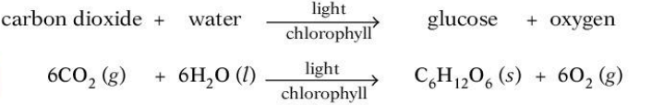

1. Carbon dioxide and methane are ‘greenhouse gases’ which contribute to global warming.
Which process does not increase global warming? （ ）
A burning fossil fuels
B decay of organic waste
C farming cattle for beef
D growing crops such as sugar cane

2. Which process removes carbon dioxide from the atmosphere? （ ）
A combustion B decomposition C photosynthesis D respiration

3. Which processes increase the amount of carbon dioxide in the atmosphere?（ ）
1 burning ethanol
2 farming cattle
3 growing trees
A 1,2 and 3
B 1 and 2 only
C 1 and 3 only
D 2 and 3 only

5. 了解自然界的水中含有哪些物质，并判断哪些是有益的，哪些是有害的。
beneficial | Harmful
1. Dissolved oxygen for aquatic life | 1. Some metal compounds are toxic
2. Some metal compounds provide essential minerals for life | 2. Some plastics harm aquatic life
 | 3. Sewage contains harmful microbes which cause disease
4. Nitrates and phosphates lead to
deoxygenation（脱氧） of water and damage to aquatic life
1. Water for human use is treated by filtration then chlorination.
Which uses do not need water of this quality? （ ）
1 water for cooling in industry
2 water for flushing toilets in the home
3 water for drinking
A 1, 2 and 3 B 1 and， 2 only C 1 and 3 only D 2 and 3 only
2. Untreated water can spread diseases such as cholera.
What can be added to drinking water to reduce the spread of such diseases?（ ）
A carbon monoxide B chlorine C nitrogen monoxide D sulfur

3. In many countries river water is used for the washing of clothes.
The same water is not considered to be safe for drinking.
Why is it not safe for drinking? （ ）
A because river water contains dissolved salts
B because river water may contain harmful bacteria
C because river water may contain small particles of sand
D because river water may contain soap from washing clothes

4. Which statements about water are correct? （ ）
1 Household water contains dissolved salts.
2 Water for household use is filtered to remove soluble impurities.
3 Water is treated with chlorine to kill bacteria.
4 Water is used in industry for cooling.
A 1,2,3 and 4 B 1,2 and 3 only C 1,3 and 4 only D 2,3 and 4 only

6. 掌握水处理的各个步骤及其所要去除的物质
Step1 Filtration(过滤)
Remove as many solid particles from the water
by filtering the water through clean gravel or sand.
Step2 Chlorination(氯化)
Add Cl₂ to kill the microbes in the water.

1. Which processes are used in the treatment of water? （ ）
A filtration and chlorination
B filtration and reduction
C neutralisation and chlorination
D neutralisation and reduction

2. - (0620- S 2013- Paper 1 (Core)/1- Q31) - AIR AND WATER
Water has been contaminated with sea- water.
Which substances can be removed by chlorination and filtration? （ ）
A bacteria, sand and sodium chloride
B bacteria and sand only
C bacteria and sodium chloride only
D sand and sodium chloride only

3. The diagram shows a stage in the purification of dirty water.
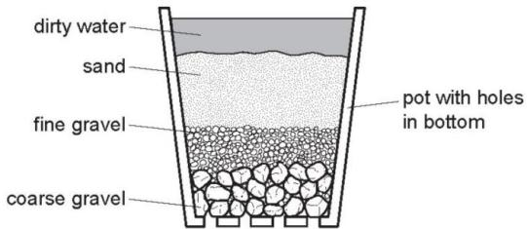
Which process does this apparatus show? （ ）
A chlorination B condensation C distillation D filtration

4. Which statements about water are correct? （ ）
1 Household water contains dissolved salts.
2 Water for household use is filtered to remove soluble impurities.
3 Water is treated with chlorine to kill bacteria.
4 Water is used in industry for cooling.
A 1,2,3 and 4 B 1,2 and 3 only C 1,3 and 4 only D 2,3 and 4 only

5. Which method of purification would produce water most suitable for drinking?（ ）
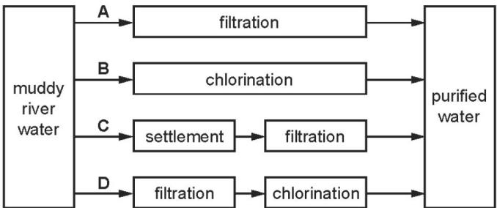

6. River water contains soluble impurities, insoluble impurities and bacteria.
River water is made safe to drink by filtration and chlorination.
Which statement is correct? （ ）
A Filtration removes bacteria and insoluble impurities, and chlorination removes soluble impurities.
B Filtration removes insoluble impurities, and chlorination kills the bacteria.
C.Filtration removes soluble and insoluble impurities, and chlorination kills the bacteria.
D.Filtration removes soluble impurities and bacteria, and chlorination removes insoluble impurities.

7. 掌握如何检验水是否纯净和是否有水存在
Effects of impurities : Increase the boiling point，decrease the melting point
Existence of water :1. Anhydrous copper sulfate
Observation : Colour change from White to Blue
2. Anhydrous CoCl₂
Observation : Colour change from Blue to Pink

1. Which statement shows that a liquid is pure water? （ ）
A It boils at ${100}^{∘}C$
B It has a pH value of 7.
C It turns blue cobalt(II) chloride pink.
D It turns white copper(II) sulfate blue.

2. Which statement about pure water is not correct? （ ）
A It condenses at ${100}^{∘}C$ .
B It freezes at $0^{∘}C$ .
C It turns cobalt(II) chloride paper blue.
D It turns anhydrous copper(II) sulfate blue.
3. Which substances can be used to detect the presence of water? （ ）
1 cobalt(II) chloride
2 copper(II) sulfate
3 litmus 4 methyl orange
A 1 and 2 B 1 and 3 C 2 and 4 D 3 and 4

4. Water is needed for industry and in the home.
Rain water is collected in reservoirs.
How is it treated before entering the water supply?
.............................................................................................................................
.............................................................................................................................[2]
State two industrial uses of water.
.............................................................................................................................
.............................................................................................................................[2]
State two uses of water in the home.
.............................................................................................................................
.............................................................................................................................[1]
In many regions, drinking water is obtained by the distillation of sea-water.
Explain how distillation separates the water from sea-water.
.............................................................................................................................
.............................................................................................................................[2]

5. Describe a chemical test which shows the presence of water.
test colour change if water is present.
.............................................................................................................................
.............................................................................................................................
.............................................................................................................................[3]
How could you show that a sample of water is pure?
.............................................................................................................................[1]
Describe how water is treated before it is supplied to homes and industry.
.............................................................................................................................
.............................................................................................................................[2]

